Merry Kiritimati!

As most PEPPers will know, Kiritimati is the I-Kiribati, or Gilbertese, translation of the word ‘Christmas.’ Kiritimati Island, in the Line Islands of Kiribati, is the first inhabited place on Earth to experience the New Year each year. It has the greatest land area of any coral atoll in the world and comprises over 70 percent of the total land area of Kiribati, even though its land mass totals only about 322 square kilometers or 124 square miles.

Kiritimati was important to the Allies in World War II for protecting the main Hawaii-Australia supply route. It was the site for nuclear testing -- sometimes without evacuation -- by the United Kingdom in the 1950’s and by the United States in 1962.

Spain has latent claims to Kiritimati that it has never pressed. The United States claimed the island under the Guano Islands Act of 1856 but ceded it to the Republic of Kiribati in the 1979 Treaty of Tarawa. The entire island is now a wildlife sanctuary.

I visited Kiritimati in 2010 as the guest of honor at the re-opening of a school completely refurbished by U.S. Navy Seabees. I also wanted to check on the planning underway for resurfacing the runway at Cassidy International Airport. I was impressed by the tremendous friendliness of the people and their efforts, together with such groups as Rotary International, to protect the island’s fragile water supply.

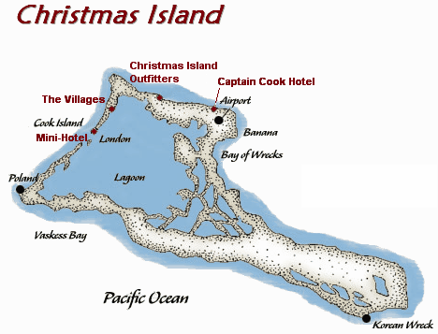
The island has the potential to relieve some of the overcrowding in other islands in Kiribati. It also has great tourism potential. Fishermen charter flights from Hawaii and beyond just to match their skills against the bonefish in Kiritimati’s massive central lagoon. The seabird population on the eastern end of the island attracts birdwatchers from around the world. The island’s mailing postmark is another potential asset. Who wouldn’t want to receive a postcard from Santa Claus’ tropical retreat?

Protecting the island’s freshwater lens, augmenting its rainwater collection, and maintaining the runway at Cassidy will be necessary if Kiritimati is to have a bright future.

In the coming New Year, PEPP expects to incorporate in Micronesia. Among other things, we look forward to working with the people of Kiribati in order to help Kiritimati develop in ways that are responsible and environmentally sustainable.

From all of us at PEPP, here’s wishing you a very Merry Kiritimati and a Happy New Year!

Richard K. Pruett
Executive Director

